# **Eight-bit Binary Adders and Analog to Digital Conversion**

◊

Prepared for:

Professor Pattengale

◊

Engineering 17L - Circuit Theory Lab Section

Tuesday 2:00 - 5:05

◊

**Vince Anicich, Fabrizio Farina, Zack Garza**

◊

Effective Date of Report:

May 20, 2014

Table of Contents

Eight-bit Binary Adders and Analog to Digital Conversion 1

Introduction / Abstract 3

Theory 4

Adders 4

Half Adders 4

Full Adders 5

Subtraction 6

Analog to Digital Conversion 7

Equipment List 8

Procedure 10

Results 11

Conclusion 13

Appendix 14

Section A: References 14

Section B: Data Sheets 15

# Introduction / Abstract

Until the 1960’s, measurement and control of physical quantities was mostly based on analog systems. In analog circuits the magnitude of the physical quantity is expressed proportionally to a voltage or current applied; since voltage and current can take any values, the measurement’s values are also continuous. For this reason analog systems are also known as *continuous-state* systems. The advent of transistors, logic gates, and integrated circuits changed radically the way of measuring and controlling physical quantities. Since most of the silicon based devices operates within a very limited voltage range -which is translated into binary numbers, the measurement value is expressed in discrete steps. Therefore, digital systems are also known as *discrete-state* systems.

In this lab the students will explore the operation of logic gates, the theory behind binary addition and subtraction, and the basic working principle of Analog to Digital Converters. With the use of a software simulator (Circuit Maker) the student will draw and simulate the circuitry of an 8-bit adder/subtractor. The students will then build and test the final working model. Moreover, through the use of an analog devise (a potentiometer) the student will simulate the measurement of a physical quantity (i.e. temperature) as a way of testing the accuracy of the Digital to Analog Converter.

# Theory

## Adders

Adders find a variety of uses, forming the fundamental building blocks of arithmetic logic units (ALUs) in computers of all sizes. In this laboratory, our goal is to find the sum of two digits using a combination of discrete circuit elements that perform logical operations. To address this task, we turn to circuit combinations that are referred to as adders – in particular, half-adders and full-adders – to develop the theory that motivated the design of this circuit.

## Half Adders

It is important to distinguish between a full adder and a half adder, particularly when it comes to summing two digits with a “carry”. In traditional decimal arithmetic, the concept of a carry is addressed by indexing digits – for example, starting at zero and incrementing by 1 digit at a time, the largest number that can be represented is 9. To address this, we use a second digit to represent the “ten's place”, and reset the digit in the “one's place” to its initial value, giving us 10. Similarly, reaching 19, the ten's place is incremented and the one's place is reset, yielding 20. In base 10, there are only finitely many numbers that can summed that do not overflow the one's place position – while it is possible to represent 4+5 with only one digit, sums such as 8+3 require another digit to communicate what the sum really is. We refer to extra digit as the “carry”, which can be generalized to number systems with arbitrary bases. For the purposes of this laboratory, we will only examine the binary case.

Figure 1: Binary Addition

| Half Adder | Inputs | Outputs | |
| --- | --- | --- | --- |
| A | B | S | C0 |
| 0 | 0 | 0 | 0 |
| 0 | 1 | 1 | 0 |
| 1 | 0 | 1 | 0 |
| 1 | 1 | 1 | 1 |

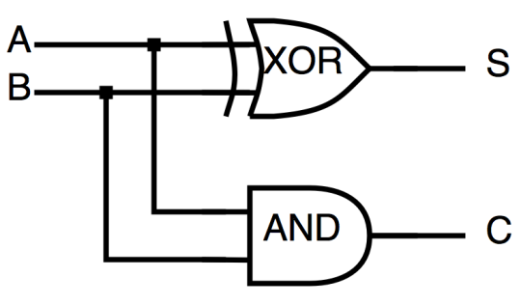 Figure 2 shows a simple implementation of a half adder that takes two inputs, **A** and **B**, and produces a sum **S** and a carry **C**. This is ideal for adding two single bytes together, but presents a problem when adding multi-digit numbers together. For example, as in traditional decimal arithmetic, overflowing the one's position contributes an additional factor of ten to the overall sum. The case is similar in binary arithmetic. However, a half adder circuit has no way to differentiate between which bits contribute more to the overall sum – or, in other words, which bits are more significant than others. While it does allow the addition of single digits, what is needed is a way for the carry to propagate through the addition of higher order (i.e., more significant) digits as they are being added.

Figure 3: Truth Table for a Half Adder

Figure 2: Logical Schematic for a Half Adder

### 

## Full Adders

| Full Adder | Inputs | | Outputs | |
| --- | --- | --- | --- | --- |
| A | B | Ci | S | C0 |
| 0 | 0 | 0 | 0 | 0 |
| 0 | 0 | 1 | 1 | 0 |
| 0 | 1 | 0 | 1 | 0 |
| 0 | 1 | 1 | 0 | 1 |
| 1 | 0 | 0 | 1 | 0 |
| 1 | 0 | 1 | 0 | 1 |
| 1 | 1 | 0 | 0 | 1 |
| 1 | 1 | 1 | 1 | 1 |

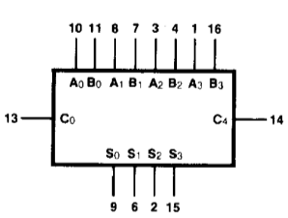 In order to account for a carry that can effectively “ripple” through a calculation, a logical circuit can be constructed that functions much like the half adder, but takes into account the possibility of a number being carried in from a previous calculation. This is denoted in Figure 6 as Cin. The truth tables for a half adder and a full adder are compared in Figures 3 and 4, and it can be seen that for all combinations of **A** and **B**, the inputs are identical. However, the functionality is extended by including the carry in as a third input, allowing multiple adders to be chained together to compute the sum of arbitrarily large digits.

Figure 4: Truth Table for a Full Adder

In this laboratory, we utilize dual inline-pin chips, equipped with four full adders each, to accomplish the task of summing together binary words consisting of 4 bits. Each adder is capable of summing together 4 bit inputs to produce a 4 bit output and a single carry bit. By sending this carry bit into a second sequence of adders, we can extend the circuit to sum together two 8 bit inputs to produce an 8 bit output and an additional carry bit. For a sequence of such adders wired in series, such that the carry out 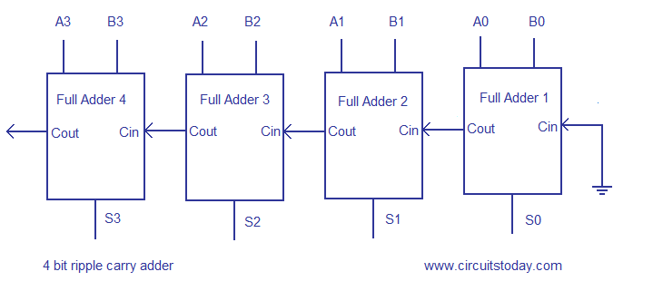of each adder is sent to the subsequent adder, the sum of the two inputs is generated in order from its least to most significant bit.

Figure 5: Pin-out Diagram

of a 4 bit Full Adder

  
Thus, given a binary input  for which the bits are represented as , an input  with the bits  a carry in **,** the digits of the sum  are given by:

Figure 6: Ripple Carry Chaining of Full Adders

That is, adding two corresponding bits in the *i*th position contribute a term of in the sum. When the sum is overflowed, the carry can be interpreted to represents an error flag, indicating, that the sum is out of range – however, the sum is still valid as a 9 bit number, where the carry denotes most significant bit. Thus, the carry makes an additional contribution of . Converting to decimal, an 8 bit input can contain any number between 0 and 255 (), and the sum can represent any number between 0 and 510 (), as it is represented by 8 bits plus a 9th carry bit. In addition mode, this represents possible input combinations, and possible outputs.

### Subtraction

| ***XOR*** | **Inputs** |  |
| --- | --- | --- |
| **SUB** | **Bi** | **Output** |
| 0 | 0 | 0 |
| 0 | 1 | 1 |
| 1 | 0 | 1 |
| 1 | 1 | 0 |

The functionality of the adder can be inverted to produce the difference **A-B**. This is done by routing each inputs of B through one branch *XOR* gate before it reaches the adder, while the other branch of each gate is wired to a mode-select switch. This schematic is shown in Figure 7 where the switch is denoted SUB. Examining the truth table for a *XOR* gate, given these inputs, shows that when the SUB switch is deactivated, the input of B is unchanged. However, when SUB is activated, the gate functions as an inverter acting on B's input.

Figure 7: Truth table of a XOR gate

In order to perform subtraction, we take advantage of a property of number's represented in two's complement. In this case, the values **A-B** can be obtained by evaluating **A +~B+1**; that is, by inverting B, adding it to A, and adding 1. The *XOR* gate accomplishes the inversion when SUB is activated, and the adder sums the results. So, in order to obtain the final value, the SUB switch is also sent to the first adder's carry in, effectively adding 1 to the result and producing the correct value. In this case, the carry now represents the “borrowed” digit in subtraction. Given an 8 bit input, the sum can then range from 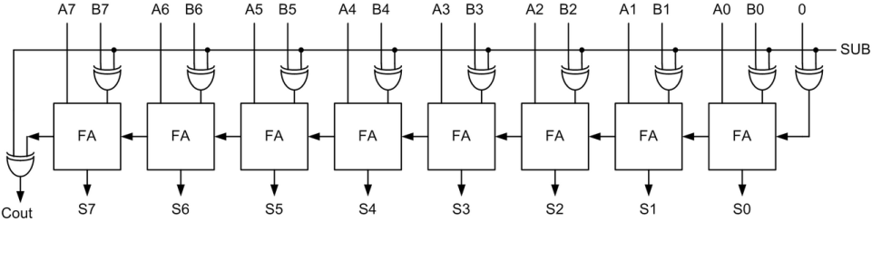-255 (when A = 0 and B = 255) to +255 (when A = 255 and B = 0), where the carry bit is now interpreted as a negative sign. While this yields the same number of possible inputs and outputs as unsigned addition, the use of one bit as a negative sign limits the absolute value of the range to 255 instead of 510.

Figure 8: Ripple Carry of Adder-Subtractor

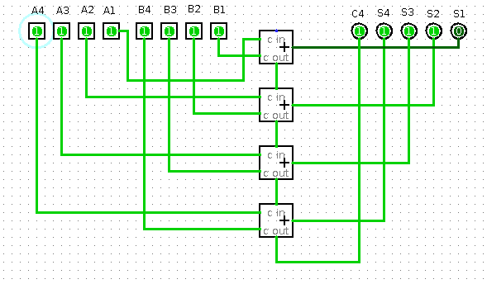

Figure 8b: Logical schematic of the Ripple-Carry Adder's functionality. The carry from the least significant bit is "rippled" through each adder, in this case, resulting in a carry out.

## Analog to Digital Conversion

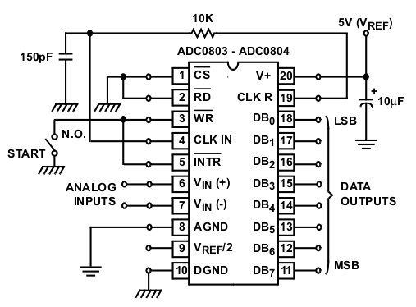 In applications, it is often necessary to collect some form physical data, such as temperature, pressure, light, or sound, and process it as digital data in order to process or perform calculations on it. For this purpose, we turn to ADCs, or Analog to Digital Converters, which take continuous signals and produce discrete output values that are proportional to the input. This provides a crucial link between components that function as transducers and those that are purely digital, such as microprocessors.

If a given ADC has *n* distinct digital outputs, the range of input signals are then partitioned into  distinct values that vary over the entire range. For example, in this circuit, the schematic in Figure 9 is used. The ADC samples a range of 5 volts and produces 8 bits of output. This gives an input resolution of volts, or about 19.5 mV. For most ADCs, the range of voltages can be customized or tared to arbitrary “zero” levels, thus providing whatever resolution is necessary for the specific application. However, there are also minimum thresholds to this resolution, as the accuracy of the ADC is dependent on the resistance and capacitance of the input, and several internal components are sensitive to noise. For this reason, many specifications distinguish the analog and digital components and advise that these components are grounded with capacitors, and often suggest using an entirely different bus for the digital ground.

Figure 9: Pin-out of Analog to Digital Converter

The final key part of the ADC's operation is the clock, which determines the rate at which an input signal is sampled. For most applications, a clock operating at a frequency that is more than twice the input signal's frequency will produce a digital output that can always be reconstructed into the original signal. The clock used determines the frequency at which the input is sampled, or the sampling rate. For this circuit, an RC filter is used, yielding a clock frequency given by .

# Equipment List

|  |  |  |  |  |
| --- | --- | --- | --- | --- |
| **Nomenclature** | **Manufacturer** | **Model/Serial #** | **Function** | **Picture** |
| 4 Bit Full Adder (x2) | Texas Instruments | SN7483 AN | Produces the sum of 4 binary inputs |  |
| 8 Bit A/D Converter | Intersil | ADC0804 LCN | Map analog input voltages to discrete digital outputs |  |
| Assorted Resistors (x4) | N/A | 3x 300 Ω, 1x 10 kΩ | Necessary for LED functionality; reduces circuit noises from back-currents. |  |
| Breadboard | Global Specialties | Proto board PB-6 | Foundation of circuit |  |
| Capacitor | N/A | 1x 114 pF | Used in auxiliary RC filter that serves as a clock for the 8 Bit A/D Converter |  |
| Circuit Maker | MicroCode Engineering, Inc. | Student Ver 6.2 | Calculating theoretical values of circuit variables. |  |
| DC Power Supply | Elenco-Precision | XP-581 | Source of power to circuits. |  |
| Digital Multimeter | GW Instek Multi Meter | GDM 393A | Measuring voltage and current of circuit elements. |  |
| Light-Emitting Diodes (x25) | N/A | N/A | State indicators for inputs inputs and outputs |  |
| Potentiometer | N/A | 5022F | Produce a continuously varying voltage input |  |
| Tri-state Switch Array (x2) | N/A | N/A | Used to furnish discrete high and low states as input |  |
| Wire Jumper Kit | Jameco Electronics | JE10 | Circuit components |  |
| Wire Stripper/Cutter | K.Miller Tool Co. | 102 | Trimming wire and stripping insulation. |  |
| XOR Gate (x2) | Texas Instruments | 7486 | Modifies Adder inputs to support subtraction mode. |  |

# Procedure

This project was built iteratively over 3 phases. First, a 4-bit adder was constructed. This took two 4 bit inputs, which were denoted as inputs **A** and **B** respectively, and produced a 4 bit output that indicated the sum of the inputs, as well as an additional bit to represent the carried digit.

The circuit was then extended to include a second adder, allowing the addition of 8 bits from each input and producing an 8 bit output and an additional carry bit. Input B was then routed through an array of *XOR* gates, which with the addition of a mode-select switch, allowed the circuit to perform addition (**A+B**) or subtraction (**A-B**).

In the final phase of the circuit's development, the tri-state switch used to control input B was replaced with a potentiometer to produce analog voltage levels. This was then routed through an analog to digital converter in order to send discrete input values to the adders, ultimately producing a sum that could be continuously varied over the input voltage range.

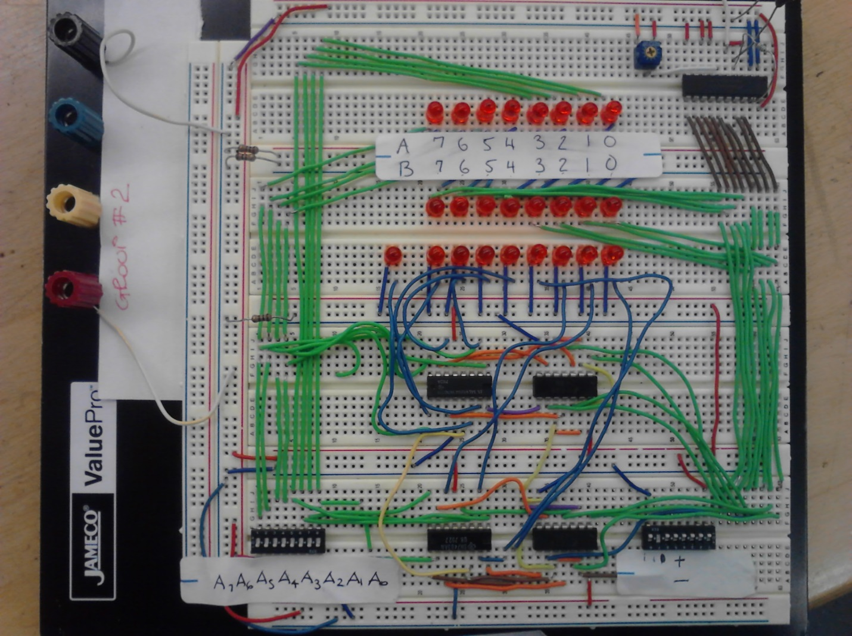

Figure 10: Completed Digital to Analog 8 Bit Adder Circuit

# Results

## 4-bit Adder

The 4-bit adder was first tested by selecting all the A’s and B’s inputs at logic level 1; in this way we verified the correct functioning and layout of all LED’s. We then proceeded with several additions by selecting the appropriate addend A and B and by verifying the sum displayed by the LEDs.

## 8-bit Adder-Subtractor

For the 8-bit adder we followed the same testing procedure developed for testing the 4-bit adder. By selecting the SUB switch we then tested the subtraction operation and obtained positive results.

## Analog to Digital Converter

After replacing the tri-state switch with the potentiometer, we first tested the 8-bit adder to verify the functionality of its arithmetic logic. By rotating the potentiometer’s knob we selected the B’s inputs sequentially ($B_{0}, B_{1}, … B_{7})$; we then verified the results of the addition operation by looking at the row of LED’s (${C_{out}, S}_{0}, S_{1}, … S_{7})$.Several arithmetic operations were made with positive results.

We then simulated a measurement of the outdoor ambient temperature to verify the working principle of the ADC and to test its accuracy. The resolution of the ADC represents how many different voltage steps are discernible as discrete outputs, and is calculated as follows:

$$ADC resolution=\frac{5.0 V}{2^{8}}=\frac{5.0 V}{256}=19.5 mV/bit$$

For convenience, the temperature range was defined from 0°C (min) to 100°C (max); in this way the binary equivalent of one degree Celsius corresponded to 2.56 bits which, in turn, corresponded to 49.9 mV voltage across the analog input (V+) at pin 6 of the ADC.

Therefore,

$$34℃→87_{(base 10)}→{01010111}_{(base 2)}→1.65 V$$

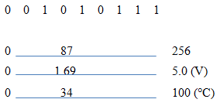We set the potentiometer to obtain the binary value of 87 displayed by the LED’s; the measured voltage across the potentiometer was 1.57 V, giving a percent error of **-4.8%.** Figure 11 illustrates number lines corresponding to the range of inputs, along with where the test values lie within these ranges.

Figure 11: Testing Analog to Digital Conversion

|  |  |
| --- | --- |
| **Output (Base 10)** | **Voltage (mV)** |
| 0 | 3.6 |
| 1 | 29.6 |
| 2 | 48.6 |
| 4 | 79.9 |
| 8 | 156.8 |
| 16 | 316.4 |
| 32 | 611 |
| 64 | 1242 |
| 128 | 2470 |
| 255 | 4960 |

Data was then taken in order to determine the continuous voltage levels that corresponded to each bit of digital output. This was done by measuring the potentiometer's voltage across digital output levels corresponding to each index digit -- that is, a measurement was taken for an output of 20, 21, 22...28-1, or equivalently, over the range of 0-255 in

decimal. Plotting these data points and interpolating via linear

regression yielded an expression for the

average voltage step required in order to index the output by an additional bit.

The slope of this fit corresponded to approximately 19.40 mV per bit, yielding an error of **0.51%** from the theoretical ADC resolution of 19.5 mV calculated above. While these results are based on the assumption that both the potentiometer and the ADC perform linearly over their respective voltage ranges, outputs produced by arbitrary voltages were in good agreement with this model.

Table 1: Voltage Levels Over Output Range

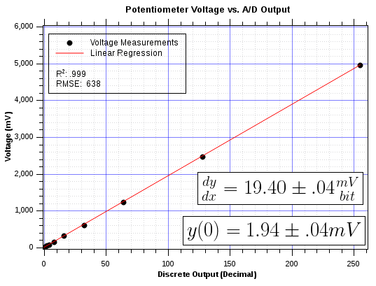

Figure 12: Plot of ordered pairs consisting of input analog voltages over the potentiometer and the corresponding binary output.

# Conclusion

The construction of this circuit brought to light many of the unforeseen difficulties that arise in large, multi-phase projects. The first phase was completed with minimal theoretical underpinnings, and functioned as desired - however, as additional specifications were created, more complexity was added to the circuit and the initial design was not ideal for further expansion. This resulted in almost a complete redesign in phase 2, which required a significant amount of planning and theoretical work in Circuit Maker.

We quickly ran into limitations in terms of both space and technology. The small form factor of the bread board required non-ideal wiring in several cases, which became problematic when the circuit malfunctioned as the number of potential failure points increased. Technology was also a limitation in this lab, as combining 16 inputs, 8 outputs, 8 *XOR* gates, 2 adders, and 24 LED state indicators (shown in the figure below) meant quickly running into the 50 device limit imposed by the student version of Circuit Maker.

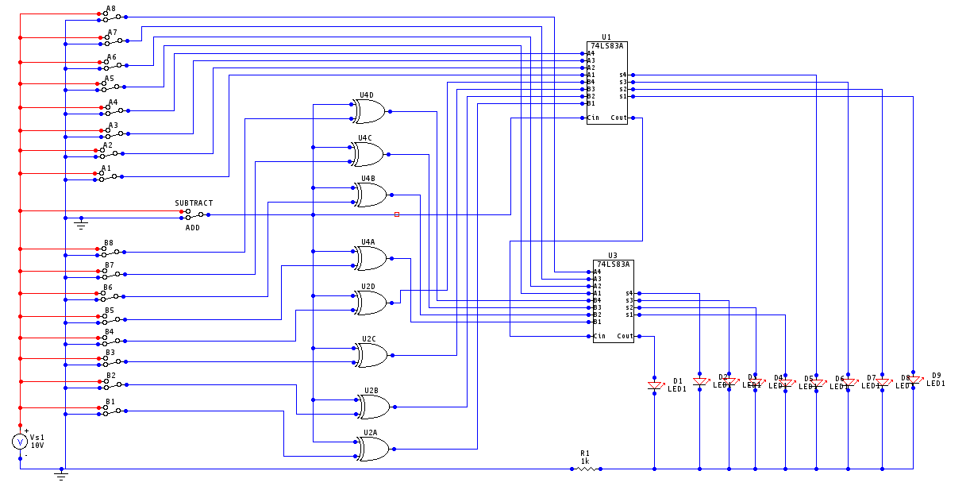 Additionally, this circuit demonstrated the vital importance of eliminating floating grounds in digital circuits. Many of the errors or apparent malfunctions of the circuit were simply the result of indeterminate floating voltages across the circuit elements. The tri-state switch, for example, was required in order to definitively ground an input as opposed to simply creating a short to deactivate it. Similarly, the adders themselves required their first carry pin to be grounded in order to produce the correct sum. This was also the case with several elements on the ADC, which required specific pins to be jumped and grounded in order to provide the proper signals to its internal circuitry.

Figure 13: Theoretical schematic made in Circuit Maker

# Appendix

## Section A: References

Nilsson, James W. and Susan A. Riedel. 2011. Electric Circuits. Ninth Edition. Pearson Education, Inc., Upper Saddle River, NJ.

Serway, Raymond and John Jewett. 2010. Physics for Scientists and Engineers. Eighth Edition. Mary Finch Publishing.

Sarma, Mulukutla S. Introduction to Electrical Engineering. New York: Oxford UP, 2001. Print.

[http://www-old.me.gatech.edu](http://www-old.me.gatech.edu/mechatronics_course/ADC_F08.pdf)

Data Sheet: 7483 Series Adder. http://faculty.spokanefalls.edu/plecoq/7483DS.pdf

Photos: <http://www.doctronics.co.uk/>

## Section B: Data Sheets

4-Bit Full Adder

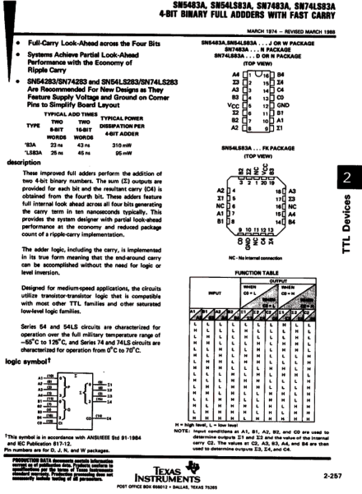

ADC Converter

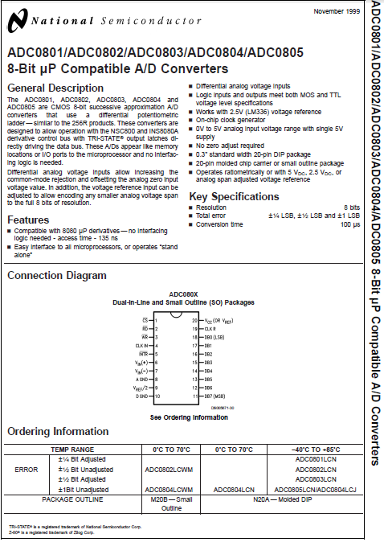

XOR Gate

